RESUME

**Bandari Anusha**

E-mail :anushabandari9640@gmail.com

Mobile number: - **+91 7997549287**

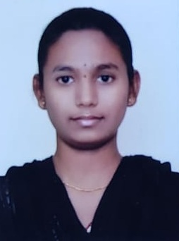

**Career Objective:**

To be an employee where I can contribute my skills and experience to the further development of the organization and achieve growth in my professional career.

**Academic Profile:**

|  |  |  |  |  |
| --- | --- | --- | --- | --- |
| **Course** | **Institution** | **Board/University** | **Year of completion** | **Aggregate (% of CGPA)** |
| B.TECH in Information Technology | Aurora’s Technological And Research Institute,Hyderbad | JNTUH | 2022 | 70% |
| INTERMEDIATE | Kakatiya Ravi Junior College,Nizamabad | Higher Secondary | 2018 | 86.6% |
| CLASS X | Nirmala Hrudaya Girls High School,Nizamabad | Secondary School of Education(SSC) | 2016 | 83% |

**Skill Sets:**

* Basics of oops concepts of Java , & MYSQL

**Achivements:**

* **Course 1:** Achived Machine Learning and Data Science with python Certificate Goeduhub Technologies,Hyderbad,May 2021
* **Course2:** Achived machine learning with python Certificate in verzeo,Hyderbad,April-May 2021

**Personal Information:**

Name : Bandari Anusha

Father Name : Bandari Madhu Sudhan

Date of Birth : 12th July 2000

Languages Known : Telugu & English

Address : HNO: 6-26-87, Canal Katta, Dubba,Nizamabad, Telangana - 503002

Hobbies : Open and Eager to learn new technologies, Listening music, playing games.

**Declaration:**

I hereby declare that all the details and particulars furnished above are correct to my knowledge. If opportunity is given, I will prove to be worthy to your confidence and satisfaction.

**Date:**

**Place: Bandari Anusha**