**Y.V. LAKSHMAN RAO** 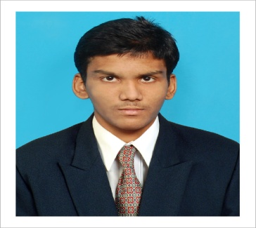

New No: 11, Old No: 6,

Arani Rangan Street, 1st lane,

Old washermenpet,

Chennai- 600 021.

Contact No. 91 8189814300

Email.id: [yvlrao2009@gmail.com](mailto:yvlrao2009@gmail.com)

linkedin.com/in/lakshmanrao

**PROFESSIONAL OBJECTIVE**

Eager to start my career through a proper platform makes me much innovative and I'm sure that my thoughts and my skills would definitely help the organization and myself in a developing path.

**EDUCATIONAL QUALIFICATION**

* Completed B. Tech in the department of Electronics and Communication Engineering (ECE) at SRM University with an aggregate of 8.8 in the year of 2018.
* Completed Higher Secondary School of Education at B.C.S.Jain H.S.S with an aggregate of 76% in the year 2014.
* Completed Secondary School of Education in B.C.S.Jain M.H.S.S with 85% in the year 2012.

**PROFESSIONAL EXPERIENCE**

* Undergone in plant training at sun smart technology at Chennai for 15days (01-06-2017 to15-06-2017) and observed study on Wireless communication.
* Undergone internship in interlace India private ltd at Chennai for 12 days (16-06-2016 to 27-06-2016) and observed the study on Networking.
* Successfully designed a Robot model in Robotics workshop conducted by SRM University in the year 2015.

**STRENGTHS**

* Quick Learner
* Team spirit
* leadership
* Amicability

**AREAS OF INTERESTS**

* Digital system
* Wireless communication
* Micro processors

**SKILL SET**

* Basics of C, Java, Python.

**CO-CIRCULAR ACTIVITIES**

* Exhibited a project in “**SMART SHOPPING SYSTEM**” in SRM UNIVERSITY in the year 2018
* Exhibited a project in “**SHORT RANGE IN 4*4 MIMO IN WIRELESS COMMUNICATION”** in SRM UNIVERSITY in the year 2017.
* Published an article about Hover boards in Adhyaay wall magazine of SRM University in the year 2017.
* Exhibited a project (Blind Bus Boarding System using RFID) in National Science Day event held in SRM University in the year 2017.
* Participated in Cerebra of Abhigyan a National level technical symposium conducted by SRM University in the year 2015.

**EXTRA-CIRCULAR ACTIVITIES**

* Active member in the Indian Society of Technical Education.
* Active member in the Rotaract club.

**PERSONAL PROFILE**

* Date of Birth: 16/01/1997
* Hobbies: Exploring about Technology, Travelling, Listening to Music, Cricket, and Reading books.
* Languages Known: English, Telugu, Tamil, Hindi, and French.

**Place: Chennai.**

**Dated:**

(Y.V.Lakshman Rao)