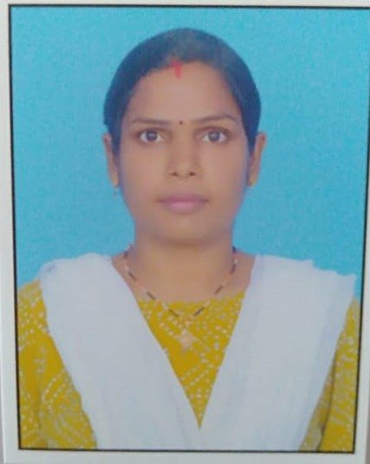

**MANJU KUMARI**

**MOB NO: 8800323809**

**E-MAIL:** [**manju9873kumari@gmail.com**](mailto:manju9873kumari@gmail.com)

**Y-Block , Mangolpuri, North West Delhi**

**Delhi -110083**

**Personal Details.**

**Date of Birth: 01-05-1995**

**Gender:** Female.

**Marital Status:** Married.

**Language:** English, Hindi, Kannada, Bhojpuri.

**Hobbies:** Reading books, updating myself with latest technologies.

**summary:**

* A good hard-working student having grit for success.
* Ability to coordinate with team members of a project to get successful results.
* Possess good knowledge and quick learner.

**Qualification:**

|  |  |  |  |  |
| --- | --- | --- | --- | --- |
| **CERTIFICATE AWARDED** | **COLLEGE/ SCHOOL** | **UNIVERSITY/ BOARD** | **YEAR OF PASSING** | **PERCENTAGE** |
| **B.E**  **(CSE)** | Proudhadevaraya Institute of Technology Hospet | [Visvesvaraya Technological University](https://vtu.ac.in/) | 2021 | 73.6 |
| **Diploma** | T.M.A.E s polytechnic Hospet | T.M.A.Es | 2016 | 84 |
| **10th Standard** | Dr. Gopinath Rao memorial high school Hospet | Karnataka Board | 2011 | 90 |

**Skills:**

**Technical Software Skills**:

* C, C++, Java Programming Languages, HTML, Python.
* Beginner with Machine Learning

**other Software Skills**:

**Microsoft Office:** Known with Word, Power Point.

**Strength:**

* Good Leadership quality
* Team worker.
* Positive minded.
* Passion for constant improvement
* Problem solving ability.
* Quick learner.
* Goal Oriented
* Hard Working.
* Good Observation.

**Workshop Seminar Attended:**

* Participated in AICTE Sponsored International Online Conference on PATTERN RECOGNITION APPLICATIONS AND METHODS on 28 and 29th Dec 2020, and presented the paper titled “VEHICLE BLACK BOX SYSTEM”.
* Participated in 3 days workshop on "Emerging Technologies in Digital World" conducted by Proudha Edutech.
* Participated in IOT Arduino workshop conducted by Terox RND & consultancy Servicespvt.ltd.

**PROJECTS:**

1)Final Year project Name: Vehicle Safety System

Description: In this paper we proposed the GPS /GSM (Global System for Mobile Communication) for driver assistance and car surveillance. Accelerometer and GPS tracking system is developed for monitor the accident.

## 

## 2) Mini Project Name: Snake game using python

Description: pip install pygame. 0nce that is done, just import Pygame and start off with your game development. Then we created the screen and created the snake and moving of snake etc.

**Internship:**

Organization: Electrosouls

Project Under Taken: Mr. Madhusudan

Technology Used: Python

Description: Worked on Pygames and Creating blogs using flask in Python Programming language.

**Career Objective:**

To obtain a creative and challenging position in an organization that gives me an opportunity for self — improvement and leadership, while contributing to the symbolic growth of the organization with my Technical, Innovative & Logic skills.

**Area of interest:**

WEB DEVELOPMENT, SOFTWARE DEVELOPENT, APP DEVELOPER

**Declaration.**

I hereby declare that all the details furnished here are true to the best of my knowledge.

Yours Sincerely,

**Manju Kumari**