**KAMINI NEERAJA**

Email: [neerajakamini@gmail.com](mailto:neerajakamini@gmail.com)

Phone: +91-9502085209

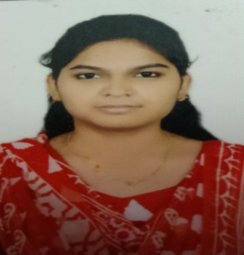

**CAREER OBJECTIVE:**

I like to work for an organization which provides me the opportunity to improve my skills and knowledge to growth along with the organization

**ACADEMIC QUALIFICATION:**

|  |  |  |  |  |
| --- | --- | --- | --- | --- |
| Course | **Institution** | **Board / University** | **Year of Passing** | **Percentage**  **(%)** |
| B.Tech, Computer Science And Engineering | Annamacharya Institute of Technology and Sciences, Rajampet. | Jawaharlal Nehru Technological University, Anantapuram | 2022 | 67  (till now) |
| Higher Secondary Education | Narayana Junior College, kurnool | Board of Intermediate Education | 2018 | 79.0 |
| Secondary Education | Keshava reddy residential school, panyam | Board of Secondary Education | 2016 | 7.3  (GPA) |

**PROJECT:**

WEATHER PREDICTION USING DEEP LEARNING ALGORITHMS

**TECHNICAL SKILLS:**

* Programming Languages : C,JAVA, Basics
* Web Technologies : HTML,CSS

**CO/EXTRA-CURRICULAR ACTIVITIES:**

* Participation in celebrations of National Mathematics Day.
* Participation in Cyber Security workshop.
* "**Go Green Program**" at our college premises under NSS camp.

**STRENGTHS:**

* Good communication skills
* Quick Learner.
* Dedication.
* Self motivated.

**PERSONAL DETAILS:**

* Name : kamini neeraja
* Date of Birth : 3th, jan,2000
* Father’s Name : kamini prathap reddy
* Gender : Female
* Languages Known : English,Hindi and Telugu
* Hobbies : Cooking, Playing Games, Reading Stories
* Nationality : Indian
* Present Address : D.No:1-4, kalavata (V), kolimigunla (M), kurnool(D),

Andhra Pradesh.

**DECLARATION**

I do here by declare that all the above mentioned particulars are true to the best of my knowledge and belief.

**DATE**  : 10-08-2021 **SIGNATURE**

**PLACE**  : kalavatala (k.Neeraja)